|  |
| --- |
| **Easy Peasy Numerology** |
| For The Entire Family ~ Pets Too! |
|  |
|  |
| **Charmaine Quintana** |
|  |
|  |
|  |

|  |
| --- |
| Easy Peasy Numerology: For The Entire Family  ISBN 1-59207-300-X © 2014 Charmaine Quintana |

**What is Numerology?**

Numerology is the study of numbers and how they relate to certain characteristics of a person or pet. Each number has its own qualities and traits, like the notes on a musical scale. And every name and birth date is like a song or melody having its distinctive sound.

The roots of numerology can be traced back some 10,000 years to Egypt and Babylonia. Pythagoras, who developed many of the basic theories that form the foundation of modern mathematics, is credited with formally organizing the field of numerology about 2600 years ago in ancient Greece. Pythagoras taught and believed that there are nine basic numbers and that all other numbers are simply repetitions of the numbers one through nine.

In numerology certain numbers are core numbers. Two of these numbers are The Personality Number, and The Life Path Number. We will use these particular core numbers as guideposts to helping us understand a person’s or pet’s personality, and tendencies of how a person or pet will respond to life’s challenges.How these numbers are calculated is shown below. We will be using the name of Chester, who is one of my best animal friends.

**The Basic Numerology Calculation for The Personality Number**

This process converts the letters of a name into a single number.   
The basic calculations are as follows:

1. The letters are first translated into numbers
2. Next the numbers are added together and
3. Finally the sum of the numbers is reduced to a single number.
4. The following chart shows which number is associated with which letter.

|  |  |  |  |  |  |  |  |  |
| --- | --- | --- | --- | --- | --- | --- | --- | --- |
| **1** | **2** | **3** | **4** | **5** | **6** | **7** | **8** | **9** |
| **A** | **B** | **C** | **D** | **E** | **F** | **G** | **H** | **I** |
| **J** | **K** | **L** | **M** | **N** | **O** | **P** | **Q** | **R** |
| **S** | **T** | **U** | **V** | **W** | **X** | **Y** | **Z** |  |

Example: CHESTER  
1. Look at the chart above to determine which number corresponds to each letter of the name:

C=3, H=8, E=5, S=1, T=2, E=5, R=9

2. Add the numbers and reduce them to ONE number:  
 3 + 8 + 5 + 1 + 2 + 5 + 9 = 33.

3. The number 33 is reduced like this: 3 + 3 = 6.

4. Therefore, SIX is the number to be analyzed.

**The Basic Numerology Calculation for The Life Path Number**

This process converts the Date of Birth into a single number. The basic calculations are as follows:

1. Reduce the month, day and year to single numbers
2. Next the numbers are added together and
3. Finally the sum of the numbers is reduced to a single number, if needed.
4. (January = 1, February = 2, March = 3, April = 4, May = 5, June = 6, July = 7, August = 8, September = 9, October = 10 or 1+0=1, November = 11 or 1+1=2, December = 12 or 1+2=3.

Example: CHESTER was born on June 21, 2000 (6/21/200).

1. 6 + (2+1=3) + (2+0+0+0=2)
2. 6 +3 +2 = 11
3. 1+1 = 2
4. Therefore, the number TWO is the number to be analyzed.

**How to analyze The Personality Number**

The Personality Number is just what it says it is, a map to your overall personality, both the inner you that you only share with close friends and family and the outer you that you share with the general public. It reveals how you choose to express yourself to the world and is also a clue to what type of work suits you best. Find your number and read the phrase that best describes that number, the planet that it is ruled by, the color and animal associated with it and the keywords that will help you on your journey of discovery through your life.

**How to analyze The Life Path Number**

The Life Path Number is that lesson or goal that you came here to learn or achieve. Unlike your name this is a number that cannot be changed. It is the energy and principle behind this number that will give purpose and meaning to your life. Take note of the key phrase and keywords because they will help to guide you through life.

What follows is the animal associated with each number for you to color. PLUS the key phrase, keywords, the planet, color and job indicators for each number. Enjoy!

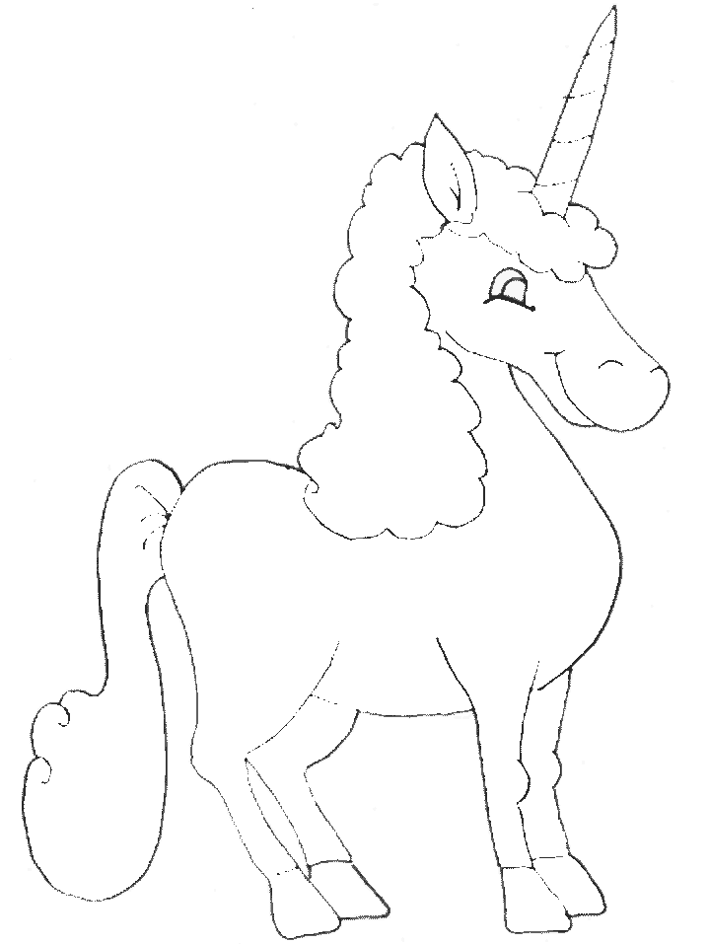

Number 1 UNICORN

|  |  |
| --- | --- |
| |  | | --- | | **1 Number One =** One is the leader.  The number one indicates the ability to stand alone,  and is a strong vibration.  **Ruled by the Sun**  **Color: Red**  **Animal: Unicorn**  **Job Indicators:** A job that allows you to take the initiative, be original, work alone, be active  and allows you the freedom to be creative.  **Keywords:** independent, creative, original, ambitious, determined, self-assured. | |
| **AngelFish1.gif**  Number 2 ANGEL FISH   |  | | --- | | **2 Number Two =** This is the mediator and peace-lover.  The number two indicates the desire for harmony.  Two is also a gentle, considerate, and sensitive vibration.  **Ruled by the** Moon  **Color: Orange**  **Animal:** Angelfish who mate for life  **Job Indicators:** jobs that require cooperation, diplomacy, attention to detail and/or  the opportunity to be in partnership.  **Keywords:** diplomatic, warm, peaceful, sensitive. | |

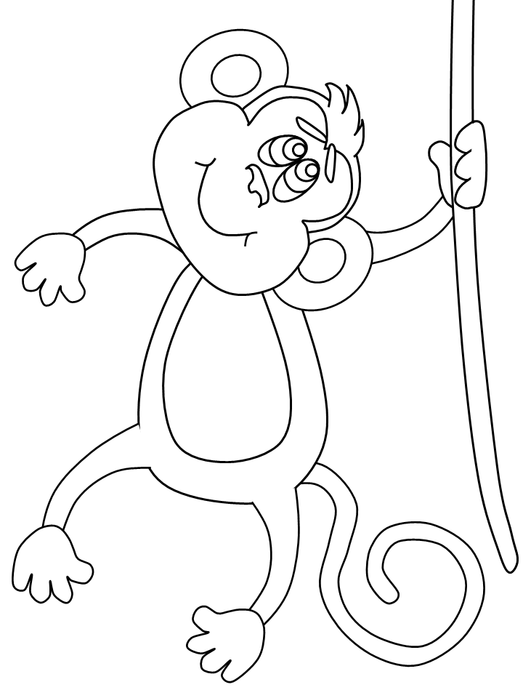

Number 3 MONKEY

|  |  |
| --- | --- |
| |  | | --- | | **3 Number Three =** The socialite, the optimist.  Threes are an outgoing vibration. (Think: Curious George)  Number Three is a curious, friendly,  kind, and positive vibration.  Threes enjoy life and have a good sense of humor. **Ruled by Jupiter**  **Color: Yellow**  **Animal: Monkey**  **Job Indicators:** Any field that involves communications, i.e., writing, acting, radio, television, art.  **Keywords:** jovial, friendly, positive,  adventurous, self-expressive. | |

|  |  |
| --- | --- |
| **color-beaver.gif**  Number 4 BEAVER   |  | | --- | | **4 Number Four =** This is the builder-worker.  (Think: Bob the Builder)  Practical, with a love of detail.  Fours are trustworthy, hard-working, and helpful.  **Ruled by Uranus**  **Color: Green**  **Animal: Beaver**  **Job Indicators:** Jobs that require, patience,  self-discipline, attention to duty and details and/or technical expertise.  **Keywords:** trustworthy, helpful, steady, logical,  self-disciplined, problem-solving. | |
|  |



Number 5 GIANT OTTER

|  |
| --- |
| **5 Number Five = T**he freedom lover.  (Think: Dora the Explorer)  The number five is an intellectual vibration.  These are "idea" people with a love of variety  and the ability to adapt to most situations.  **Ruled by Mercury**  **Color: Turquoise**  **Animal: Giant Otter**  **Job Indicators:** Any field that involves, travel, speculation and constant change, sales and marketing  **Keywords:** adaptable, freedom-loving, romantic, resourceful, witty, fun-loving, flexible, accommodating |

|  |
| --- |
|  |



Number 6 SWAN

|  |
| --- |
| **6 Number Six = T**he peace lover.  The number six is a nurturing, loving, stable,  artistic and harmonious vibration.  **Ruled by Venus**  **Color: Indigo**  **Animal: Swan**  **Job Indicators:** Any field that caters to the needs of people, artistic and/or writing professions  **Keywords:** artistic, compassionate, stable, family-loving, trustworthy, domesticated. |



Number 7 HORSE

|  |  |
| --- | --- |
| |  | | --- | | **7 Number Seven =** This is the deep thinker.  (Think: Pythagoras the Father of Western Numerology)  The number seven is a spiritual vibration.  These people are not very attached to material things. They are introspective, and generally quiet.  **Ruled by Neptune**  **Color: Violet**  **Animal: Horse**  **Job Indicators:** Jobs that require mental analysis,  in-depth thinking, specialist and/or expert in a field.  **Keywords:** unusual, introspective, intuitive,  psychic, wise, reserved. | |



Number 8 ELK

|  |  |
| --- | --- |
| |  | | --- | | **8 Number Eight =** The executive.  Number Eight is a strong, successful,  and material vibration.  **Ruled by Saturn**  **Color: Pink (and Brown)**  **Animal: Elk**  **Job Indicators:** Positions that require you to be the vision holder for the organization or your own business.  **Keywords:** ambitious, business-minded, practical,  leading, authoritative, successful, courageous, entrepreneur, organized. | |



Number 9 PENGUIN

|  |  |  |  |
| --- | --- | --- | --- |
| |  |  |  | | --- | --- | --- | | |  | | --- | | **9 Number Nine =** The teacher.  Number Nine is a tolerant, somewhat impractical,  and sympathetic vibration.  **Ruled by Mars**  **Color: Gold, All Pastels**  **Animal: Monarch Penguins**  **Job Indicators:** Public service of any kind and also allows you to be in the leadership role.  **Keywords:** Jack of all trades, humanitarian, sympathetic, helpful, emotional,  tolerant, active, determined. | |  | |

|  |
| --- |
| ************************************************************************************** |
|  |

Thank you for joining me today. Numerology is an exciting and rewarding tool to help you understand yourself and the other people around you including your pets. I also want you to remember that this lesson is an extremely abbreviated overview of numerology.

|  |  |
| --- | --- |
| Me and Gigi 12 23 11.jpg | If you would like to know more about your numbers and how they influence your life, please feel free to contact me at:  [Clquintana54@msn.com](mailto:Clquintana54@msn.com) |

|  |  |
| --- | --- |
| CrSpFam2.jpg | Graphic layout & publishing of  Easy Peasy Numerology For The Entire Family provided by  Laurie Story Vela & Creative Spirit Families http://creativespiritfamilies.com |